**Trends on the evolution of education for 4- to 5-year-old children in Zimbabwe**

Early childhood education (ECE) is a critical foundation for a child's future success, playing a key role in cognitive, social, and emotional development. Within the framework of Sustainable Development Goal 4 (SDG 4), which aims to ensure inclusive and equitable quality education for all, this report analyzes trends in the education of Zimbabwean children aged 4 to 5 years, focusing on literacy and numeracy, physical development, socio-emotional development, and learning achievements.

**Overview of ECE in Zimbabwe**

ECE in Zimbabwe is offered through standalone centers, infant schools, and all primary schools across the country. However, access remains limited, especially in rural areas, due to inadequate infrastructure, insufficiently trained teachers, and underfunding. Despite the government's recognition of ECE's importance, there is a significant gap between policy and practice, leading to disparities in educational quality (UNICEF, 2019).

**Methodology**

This report examines data from the 2019 Zimbabwe MICS6 survey, focusing on four performance indicators, namely literacy and numeracy, physical development, socio-emotional development, and learning achievements. The sample includes children aged 48 to 60 months (4 to 5 years), for a total of 1,252 children.

**Findings**

The analysis depicted in the panel below reveals the following trends across the four key performance indicators:

1. **Literacy and Numeracy:**
   * **Trend:** A significant positive trend is observed, with the proportion of children meeting international milestones increasing with age.
   * **Concern:** Despite the positive trend, overall performance is low, with only 23.3% of children reaching these milestones.
2. **Physical Development:**
   * **Trend:** There is a constant increase in physical development milestones, with 60-70% of children meeting international standards, peaking around 52 months.
   * **Strength:** This upward trend is promising, indicating consistent improvement with age.
3. **Socio-Emotional Development:**
   * **Trend:** A concerning negative trend is observed, with socio-emotional development milestones decreasing with age. This trend is statistically only at the 10% level.
   * **Implication:** The decline suggests the need for targeted interventions to prevent further deterioration.
4. **Learning Achievements:**
   * **Trend:** Learning performance remains high and stable across the age range, with 78-88% of children meeting international milestones.
   * **Observation:** A simple OLS regression shows that learning achievements are not significantly affected by age within this group.

**Implications and Recommendations**

Zimbabwe is making progress in certain areas of early childhood education, particularly in physical development and learning achievements. However, the low performance in literacy and numeracy, along with the decline in socio-emotional development, highlights critical areas that require immediate attention.

* **Targeted Interventions:** Focused effort is needed to boost literacy and numeracy among 4- to 5-year-olds, with particular attention to the disparities in access and quality of education.
* **Addressing Socio-Emotional Decline:** Investigating and addressing the factors contributing to the decline in socio-emotional development is essential to ensure child development and all dimensions.

**Conclusion**

While there are positive trends in certain areas, significant work remains to be done to ensure that all children in Zimbabwe have the opportunity to meet key developmental milestones. By addressing the challenges identified in this report, Zimbabwe can make substantial strides toward achieving SDG 4 and improving the future prospects of its youngest citizens.

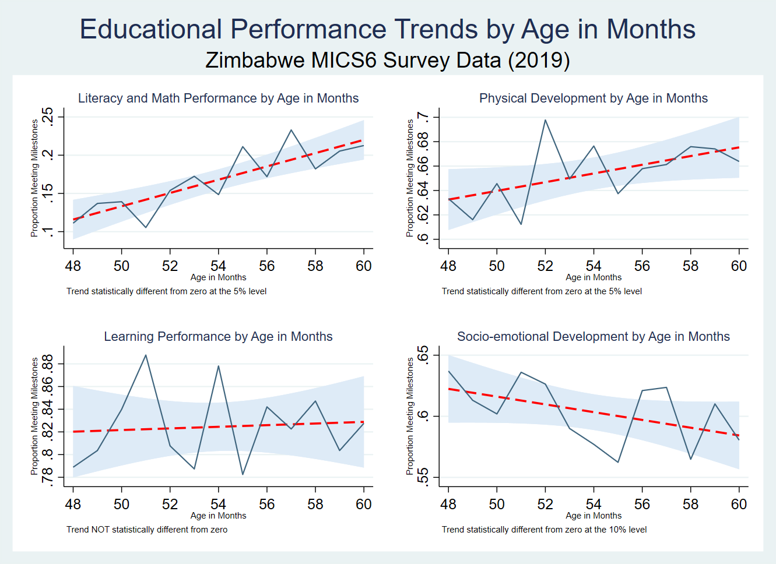

**Appendix[1]**

* Literacy and math performance: Children are identified as being developmentally on track based on whether they can identify/name at least ten letters of the alphabet, whether they can read at least four simple, popular words, and whether they know the name and recognize the symbols of all numbers from 1 to 10. If at least two of these are true, then the child is considered developmentally on track.
* Physical development: If the child can pick up a small object with two fingers, like a stick or a rock from the ground and/or the mother/caretaker does not indicate that the child is sometimes too sick to play, then the child is regarded as being developmentally on track in the physical domain.
* Social-emotional development: Children are considered to be developmentally on track if two of the following are true: If the child gets along well with other children, if the child does not kick, bite, or hit other children and if the child does not get distracted easily.
* Learning performance: If the child follows simple directions on how to do something correctly and/or when given something to do, is able to do it independently, then the child is considered to be developmentally on track in this domain.

# Bibliography

James Heckman, P. S. (2013). Understanding the Mechanisms through Which an Influential Early Childhood Program Boosted Adult Outcomes. *American Economic Review*, vol. 103, no. 6 (pp. 2052–86).

Nations, U. (10 August 2022). *The 17 Goals. Sustainable Development Goals.* United Nations.

UNICEF, Z. N. (2019). *Zimbabwe Multiple Indicator Cluster Survey 2019, Survey Findings Report.* Harare, Zimbabwe: ZIMSTAT and UNICEF.

1. (UNICEF, 2019)